VARUN KUMAR

2K19 / IT / 140

**OOP LAB 1**

1. **To print the ASCII values of a character entered by user.**

CODE –

#include <stdio.h>

int main() {

char c;

scanf("%c", &c);

printf("ASCII value of %c ---> %d", c, c);

return 0;

}

INPUT - D

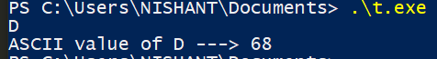OUTPUT -

1. **To print alternate characters of your name**

CODE –

#include <stdio.h>

#include<string.h>

int main() {

char myname[50];

printf("ENTER YOUR NAME : ");

fgets(myname, sizeof(myname), stdin);

int len=strlen(myname);

for(int i=0 ; i < len ; i++){

if(i%2==0) printf("%c",myname[i]);

}

return 0;

}

INPUT – VARUN

OUTPUT -



3. **To create a structure student with certain attributes of your choice (read from user) and print them.**

CODE –

#include <stdio.h>

struct student {

char name[25];

int roll;

float marks;

};

int main() {

student s;

printf("Enter name -> ");

fgets(s.name, sizeof(s.name), stdin);

printf("Enter Roll number -> ");

scanf("%d", &s.roll);

printf("Enter marks -> ");

scanf("%f", &s.marks);

printf("Name: ");

printf("%s", s.name);

printf("Roll number: %d\n", s.roll);

printf("Marks: %.1f\n", s.marks);

return 0;

}

INPUT - Enter name -> varun kumar

Enter Roll number -> 140

Enter marks -> 95

OUTPUT –

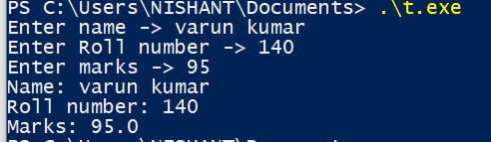

4. **To modify the above 3 rd program to take data of 5 students and print it using array of object concept.**

CODE –

#include <stdio.h>

struct student {

char name[25];

int roll;

float marks;

};

int main() {

student s[5];

for(int i=0 ;i<5 ;i++){

printf("\n%d Student :-- \n",i+1 );

printf("Enter name -> ");

gets(s[i].name);

printf("Enter Roll number -> ");

scanf("%d", &s[i].roll);

printf("Enter marks -> ");

scanf("%f", &s[i].marks);

getchar();

}

for(int i=0 ;i<5 ; i++){

printf("%d Student :-- \n",i+1 );

printf("Name: ");

printf("%s\n", s[i].name);

printf("Roll number: %d\n", s[i].roll);

printf("Marks: %.1f\n", s[i].marks);

}

return 0;

}

INPUT –

1 Student :--

Enter name -> varun kumar

Enter Roll number -> 140

Enter marks -> 86

2 Student :--

Enter name -> vansh kohli

Enter Roll number -> 96

Enter marks -> 74

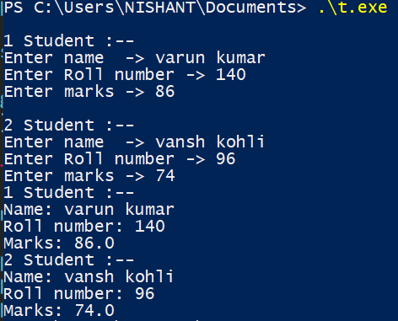OUTPUT –

5. **To modify the above program further to created a nested structure called address and print the fields from that.**

CODE –

#include <stdio.h>

struct student {

char name[25];

int roll;

float marks;

struct address{

char HouseNo[5];

char Area[50];

}a;

};

int main() {

student s[5];

for(int i=0 ;i<5 ;i++){

printf("\n%d Student :-- \n",i+1 );

printf("Enter name -> ");

gets(s[i].name);

printf("Enter Roll number -> ");

scanf("%d", &s[i].roll);

printf("Enter marks -> ");

scanf("%f", &s[i].marks);

getchar();

printf("Enter HouseNo ->");

gets(s[i].a.HouseNo);

getchar();

printf("Enter Area ->" );

gets(s[i].a.Area);

getchar();

}

for(int i=0 ;i<5 ; i++){

printf("%d Student :-- \n",i+1 );

printf("Name: ");

printf("%s\n", s[i].name);

printf("Roll number: %d\n", s[i].roll);

printf("Marks: %.1f\n", s[i].marks);

printf("HouseNo : %s\n",s[i].a.HouseNo );

printf("Area : %s\n",s[i].a.Area );

}

return 0;

}

INPUT –

1 Student :--

Enter name -> varun kumar

Enter Roll number -> 140

Enter marks -> 86

Enter HouseNo ->b68

Enter Area ->Ganesh Nagar

2 Student :--

Enter name -> vansh kohli

Enter Roll number -> 86

Enter marks -> 74

Enter HouseNo ->s70

Enter Area ->pandav nagar

OUTPUT –

